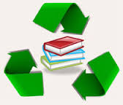
Encourage Summer Reading! 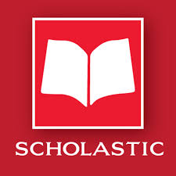

RECYCLE Your Books
and visit
Center School’s B.O.G.O. SCHOLASTIC BOOK FAIR
May 22nd _ 24th

Dear Parents of Center School Students: May 2017
Reading plays a critical role in the education of children, and providing summer access to books is the first step in making sure every child has the chance to continue reading when school ends in June.

This year, the Center School Library would like to continue our “Books for Keeps” donation program by collecting gently used, age-appropriate (K-3), children’s books from parents, grandparents, guardians, and friends who no longer use them. This is our 5th year of the program and each year we’ve received enough books to send all Center School students home in June with a few books to read and keep.

As another way to encourage summer reading, Center School will again be holding a “Buy One, Get One Free – B.O.G.O.” Scholastic Book Fair on May 22-24 (daily schedule to follow). For every book your child purchases, you will get another one for FREE!

We hope you will attend the B.O.G.O. Book Fair with your child and also consider donating any children’s books you no longer need. Donations can be left at the school’s front office or brought up to the library. Please feel free to email (colleenjohns@oldrochester.org or erinbarrows@oldrochester.org ) or call us (508-758-2521) with any questions. Thank you very much for your help. KEEP READING!!

Mrs. Colleen Johns and Mrs. Erin Barrows
Center School Library

